Technology and Innovation Analysis

Overview:
The Mount Alexander Sustainability Group (MASG) website serves primarily as an informational platform that communicates the organisation’s mission, projects, and opportunities for community involvement.
- Clear structure: The homepage and main sections clearly outline sustainability goals (aiming to achieve net zero emissions by 2030) and key focus areas, making it easy for users to understand MASG’s objectives.
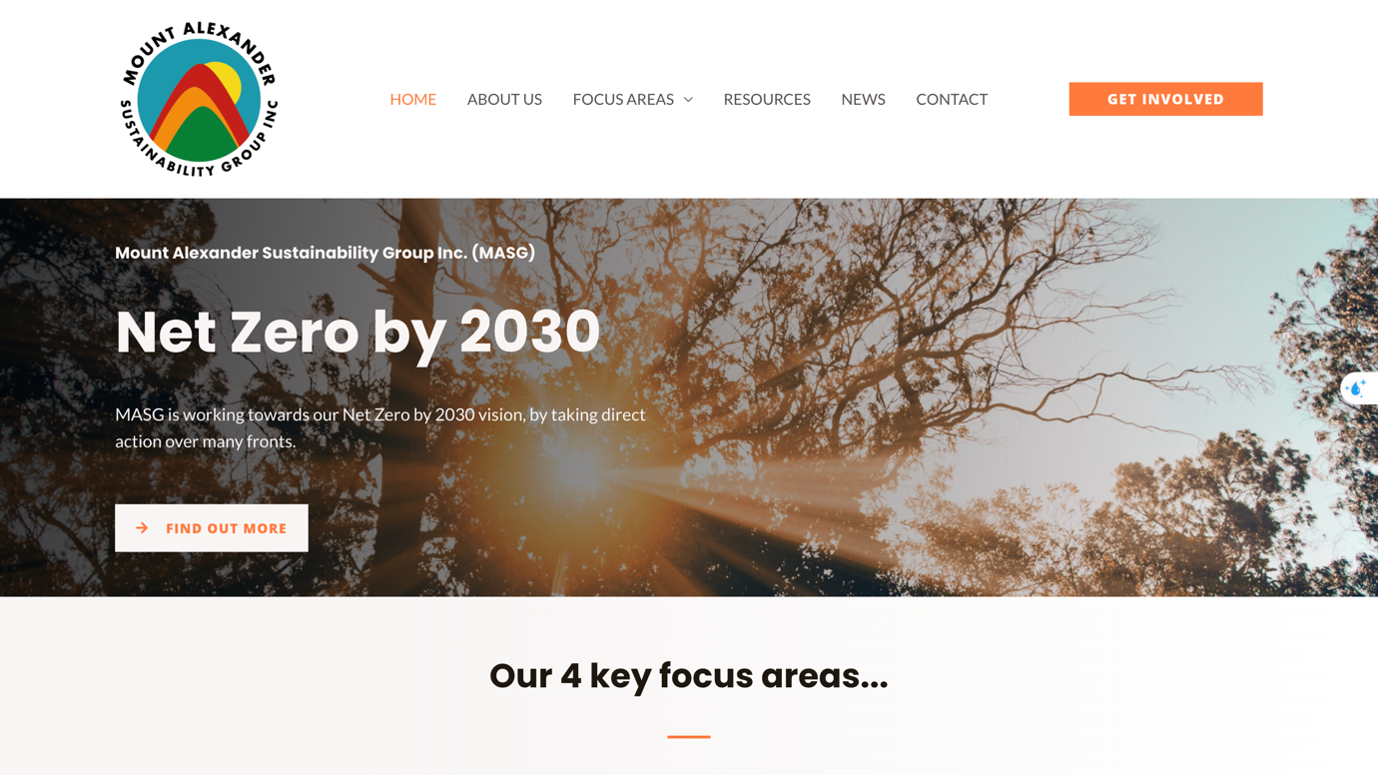
- Organised content: Information is categorised by topics like waste reduction, renewable energy, and community projects.
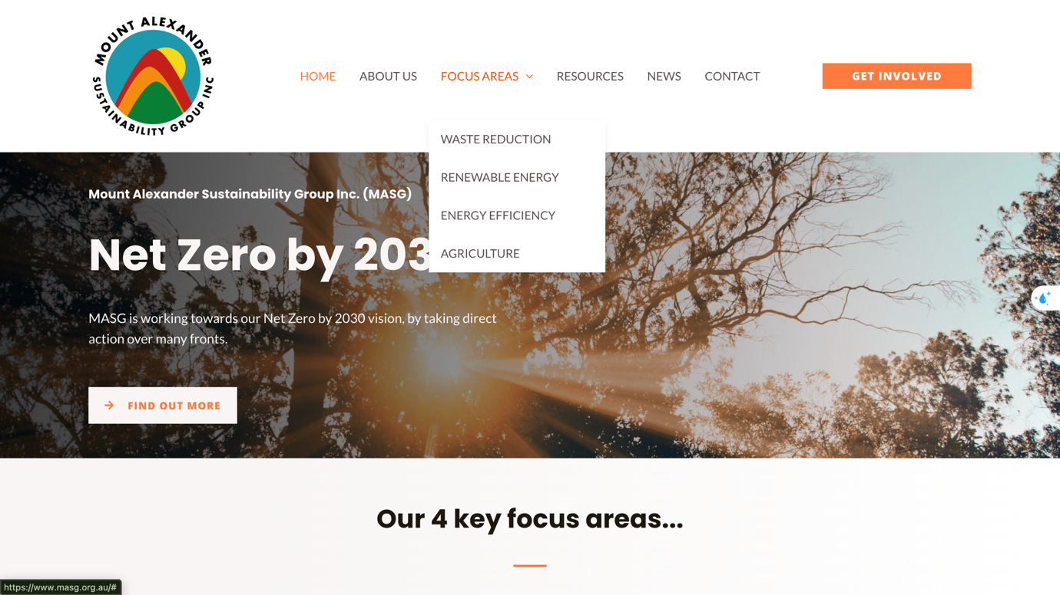
- Educational resources: Guides on energy efficiency and sustainable practices are available, supporting community education and awareness.
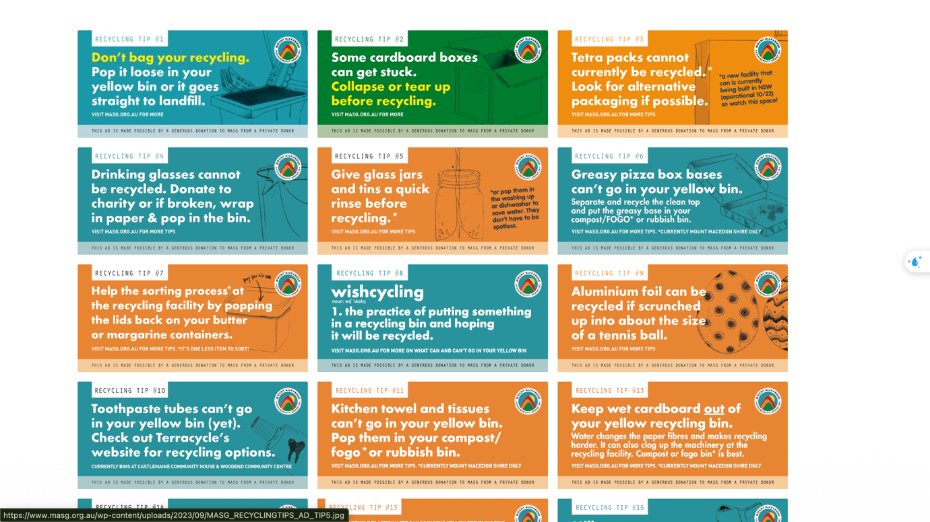

- Community focus: Calls-to-action like volunteering, membership, and donations are included, encouraging basic engagement.
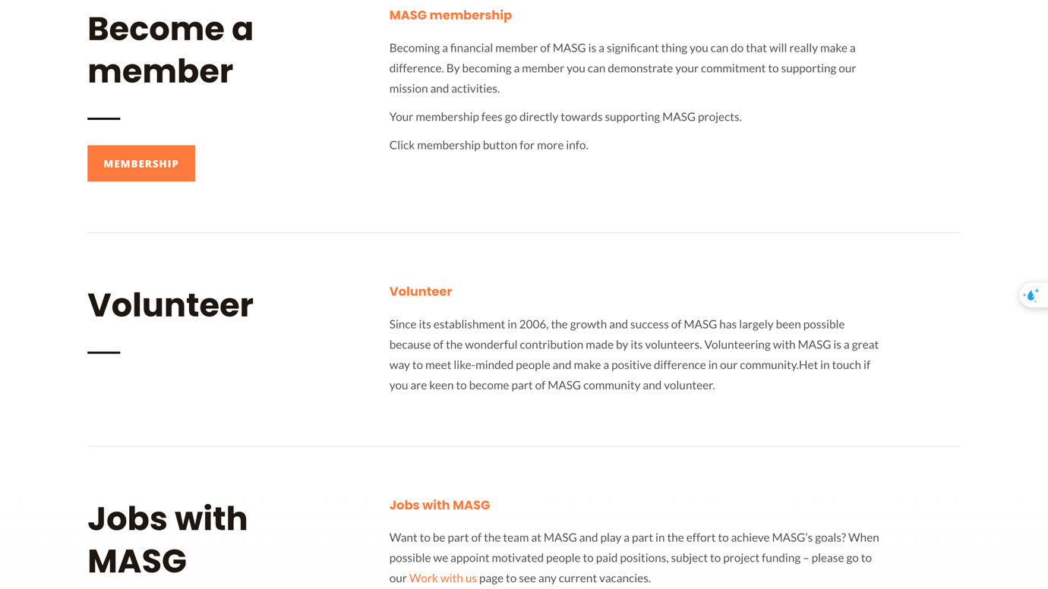

As can be seen from the graphs, the website relies heavily on text with minimal visual appeal (outdated design). Therefore, users are mostly reading static content; there’s little interactivity to engage them, such as Volunteer in “Support Us” which is in the bottom of the page rather than have a specific position in top homepage (Passive UX) that reduces retention, especially for younger, digitally-savvy users. In addition, there are no advanced digital tools such as data dashboards, interactive maps, or sustainability metrics so the present visualisation makes it harder to communicate MASG’s impact effectively (Limited technology integration) and some social media links exist but are not well integrated and attractive for audience, limiting opportunities for multi-channel interaction such as blog or direct discussion form in the home page.

Benchmarking Analysis
A benchmarking analysis was conducted by comparing MASG with several sustainability organisations such as Geelong Sustainability, Yarra Energy Foundation, Community Power Agency, Environment Victoria, Zero Carbon Merri-Bek and WRI (World Resources Institute). However, there are two websites can support MASG to identify performance gaps and opportunities for improvement.

Comparison table for MASG, Geelong Sustainability and WRI (World Resources Institute):
Feature | MASG Website | Geelong Sustainability | WRI Website
Purpose | Informational hub for local sustainability, net zero by 2030  MASG | Community-led sustainability projects, renewable energy, local events  GS | Global environmental research, policy, data-driven sustainability insights  WRI
Design & Visual Appeal | Text-heavy, outdated layout | Modern, visually engaging with infographics and photos | Highly modern, clean, professional, with data visualisations and interactive graphics
Content Organisation | Categorised by waste, renewable energy, community projects | Clear sections: projects, events, educational resources | Well-structured by topic, research, publications, tools, and initiatives
Interactivity | Low; mostly static pages | Moderate; event registrations, interactive maps | High; interactive dashboards, maps, tools, data portals
Digital Tools & Metrics | None; lacks dashboards or visual impact metrics | Some reporting dashboards, event calendars | Advanced tools: data dashboards, maps, real-time metrics, global indicators
Community Engagement | Volunteer, membership, donations; minimally highlighted | Event sign-up, volunteer, donate; visually prominent | Donate, subscribe, participate in research or policy campaigns; well-integrated
Social Integration | Basic social media links | Integrated feeds, newsletters | Strong social media, shareable resources, email subscriptions
User Experience (UX) | Passive; no search or filters | Moderate; search and event filters available | Highly user-focused; search, filters, topic portals, interactive maps

Opportunities for Improvement

MASG’s website currently functions as an informational hub, but it lacks modern technology, interactive features, and a user-centred design. Therefore, the team can enhance engagement and communication of impact, the site could be modernised with responsive layouts, visual storytelling, interactive elements and integrating digital tools such as dashboards and visual metrics in order to showcase emissions reduction, renewable energy adoption, and other sustainability outcomes. Next, there are some good features like filters, search tools, and interactive project maps would help visitors find content more efficiently, and more prominent calls-to-action alongside integrated social media feeds could further encourage community interaction. By improving the user experience and leveraging digital tools like Geelong Sustainability and WRI, MASG could communicate its sustainability objectives more effectively to increase engagement and align the website with its mission.

